6 AM-9 AM (Wake-up Y’all)

9 AM- 10 am In Case You Did Not Know

10 AM-11 AM (Kingdom Teachings With Pastor Myles Monroe)
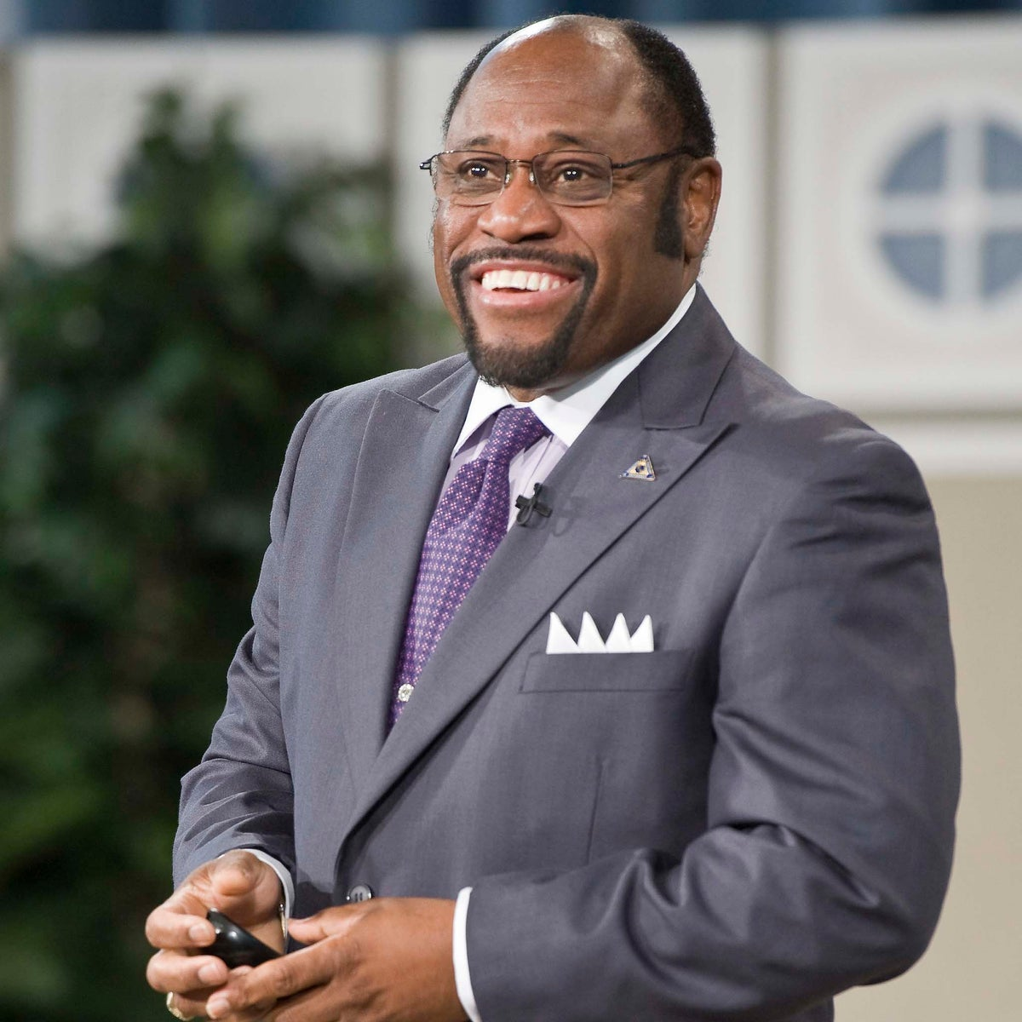
11 AM – 12 PM (Lunch with Jane Peter)

12 PM – 1 PM (Marriage talk with Dustin Scott)

1 PM- 2 PM (Testimonies with Stan Lewis)-

2 PM – 3 PM (Bragging on My Kids)- (Please, find a free picture like this and change it on gkpradio as well)

3 PM – 5 PM (4-Point Connect to Heaven by Evan)
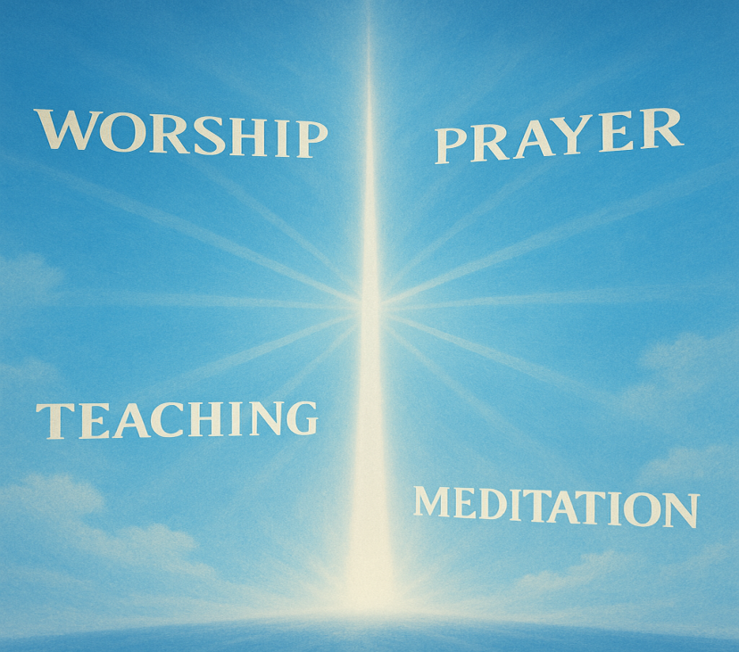
5 PM – 6 PM (Sheffield Family Hour by Pastor George)
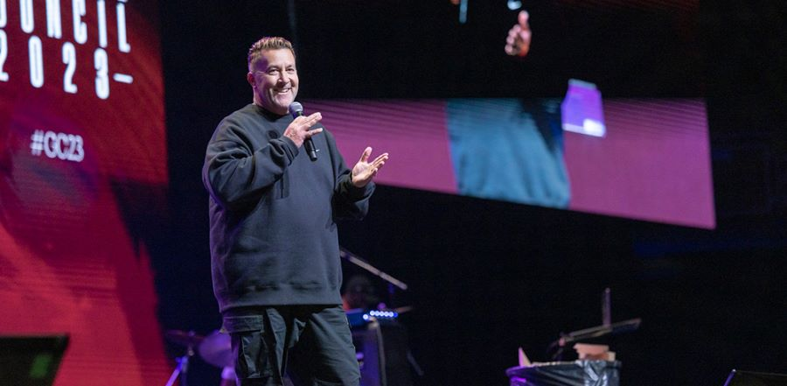
6 PM – 7 PM (Youth Corner by Melissa Burt)

7 PM – 8 PM (Let’s Talk Money by Steve Richards)

8 PM- 8:30 PM Bed Time Prayer, Children
8:30 PM- 9:00 PM Bed Time Prayer for Youth

8 PM – 9 PM (My Spouse, My Heart by Jeff and Suzie Spencer)

9 PM – 10 PM (Meditation & Relaxation by Joyce Smith)

10 PM – 12 AM (Praise & Worship Music, Played by the radio)


No One in the Studio, (REPEAT SHOWS)
12 AM-3 AM (Wake-up Y’all)
3 AM-4 AM (Kingdom Break Wit Pastor Myles Monroe)
3 PM – 5 PM (4-Point Connect to Heaven by Evan)
4 AM – 5 AM (Marriage talk with Dustin Scott)
5 AM- 6 AM (Testimonies with Stan Lewis)

